Week 1 Homework | 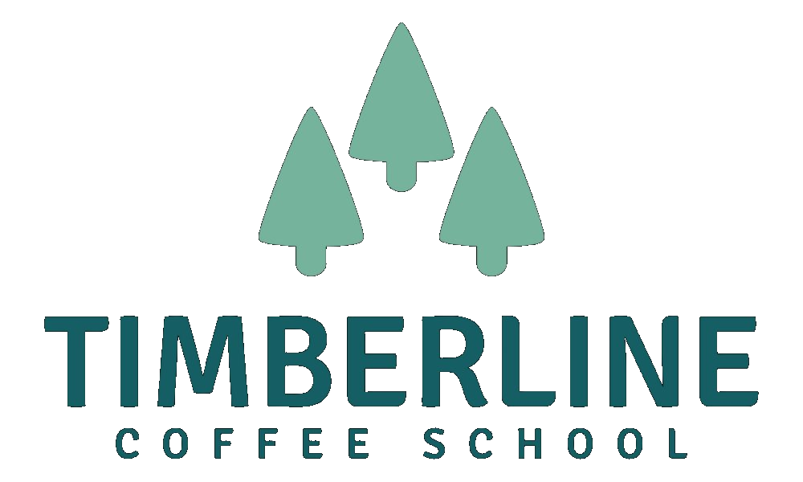

Concept Brief
Use this template to work through the four parts of your Concept Brief. Don’t overthink the format — honest, specific answers are more useful than polished ones. You’ll bring this to the live call, so aim to have something real enough to defend when the group asks questions.
01 Who is this shop for?
Describe one specific person — not a category. Give them a name if it helps. What does their day look like? What are they looking for that they’re not finding somewhere else right now?

Example: This shop is for Maria, 34, who works from home three days a week. She’s tired of driving to a chain where she feels invisible, and she doesn’t want somewhere so trendy it feels like she has to perform being cool. She just wants genuinely good coffee, a seat that was thought about, and staff who remember her order by week three.

02 Three things you will do really well
These are the things your shop is committing to. Be specific — “great coffee” doesn’t count on its own. What kind? Made how? For whom?
1. First commitment

2. Second commitment

3. Third commitment

03 Two things you are consciously not doing
Every choice to be something means choosing not to be something else. What will your shop say no to — even if it might make money? This is how you know your concept is real.
1. We are not doing…

2. We are not doing…

04 Your two-sentence description
How would you describe your shop to someone you just met — in two sentences or less? Pretend you’re at a dinner party and someone asks what you’re working on. You’ve got thirty seconds.

Reminder: Your first draft will probably feel too vague. That’s completely normal. The goal isn’t to have it perfect — it’s to have something real enough to bring to the group and test.

Timberline Coffee School — Opening Your Coffee Shop Cohort — Week 1

